ACTIVITY 3

COINS AND CARDS

# DIRECTIONS

Have one group member upload this docx file to your Google Drive and share it with your groupmates and your instructor. Name your document “**GroupX_Activity3”** (where X is your group number). Work together to type up your responses to each question. Download your document as a PDF and submit this to Canvas individually.

# PART 1: COIN FLIPPING

When setting up a sampler in TinkerPlots it is important to think about characteristics of the object (and/or process) that you want to model. In this first part of the activity, we are going to set up a model using TinkerPlots that mimics flipping a fair coin 10 times.

1. Use the space below to make a list of characteristics of a coin that you think would be important to capture in a model if you want to mimic the process of flipping a fair coin 10 times and recording the outcomes of each flip.

Your instructor is now going to guide the class in using the TinkerPlots sampler tool to create various models that mimic flipping a fair coin 10 times and then simulating trials from that sampler. Please feel free to use the space below to take notes throughout this process.

1. Let’s take a moment to reflect on one of the TinkerPlots samplers you created as a class.
2. Copy and paste a picture of one of the TinkerPlots samplers the class created that accurately mimics flipping a fair coin 10 times.
3. State what the repeat and draw values are set to and why.
4. Describe what elements you used to populate the device in your sampler and why.

1. State whether you set the device in your sampler to sample with or without replacement and why.
2. Run a single trial. A *trial* in this simulation ends when your model has generated data for 10 coin flips. Create a plot of the results of the simulated trial that allows you to see the number of times each outcome (heads and tails) occurred and paste that below.

Now, use TinkerPlots to collect the results of the number of heads that occur in 100 trials of flipping 10 coins.

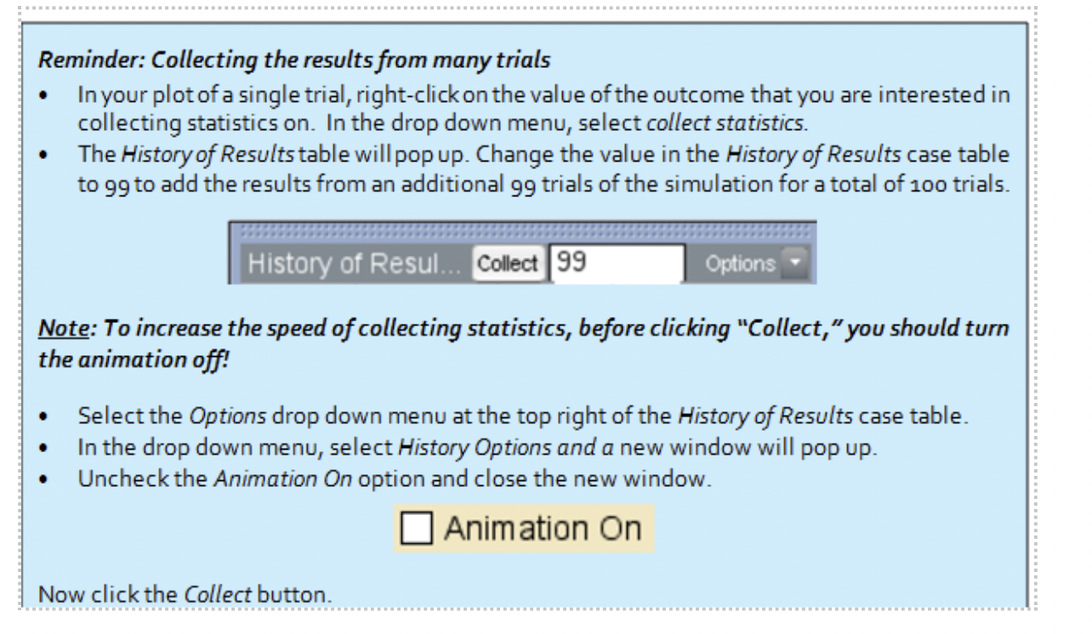

1. Create a plot of the results from 100 trials of the simulation and paste it below.
2. What does a dot in your plot above represent? Explain how a dot in this plot differs from a dot in your plot from question 3.
3. Compare and contrast your plot from Question 4a with your conjectured plot of the distribution of the number of heads in 100 trials in your pre-work assignment (Question 8). How did you do? What surprised you?

# PART 2: COUNTING HEARTS

Now you will use TinkerPlots to simulate drawing ten cards (without replacement) from a standard deck of 52 playing cards. You can then use the data generated by the simulation to check your initial intuitions about what would happen if you wanted to count the number of *Hearts* that occur when ten. cards are dealt.

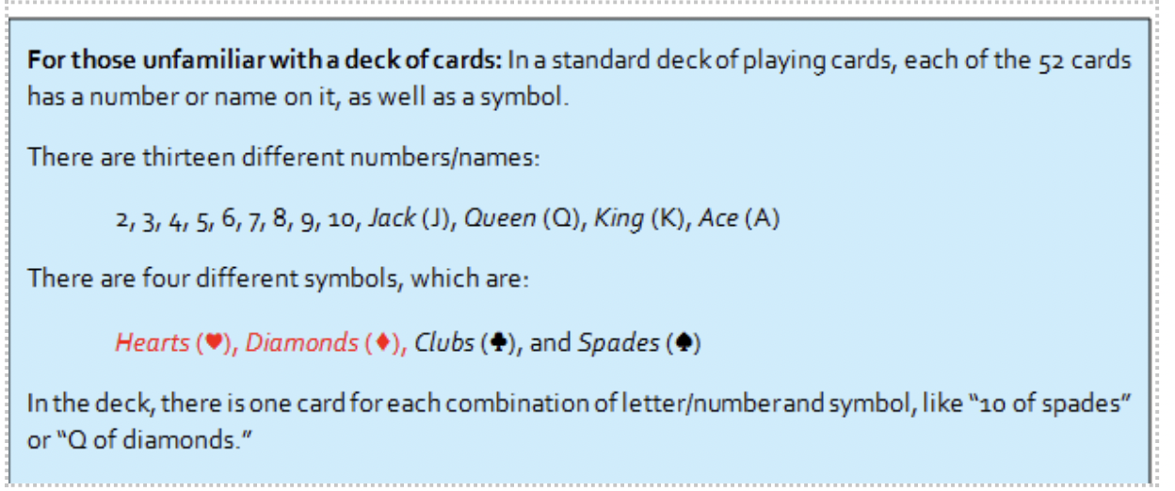

1. Prior to working in TinkerPlots, take a minute to make sure everyone in your group is familiar with a standard deck of playing cards and answer the following questions:
   1. How many *Queens* are in a standard deck of 52 playing cards?
   2. How many *Hearts* are in a standard deck of 52 playing cards?
   3. How many cards are *Red* in a standard deck of 52 playing cards?

## SETTING UP THE MODEL

1. Create a sampler in TinkerPlots to simulate dealing 10 cards from a standard deck of playing cards with the goal of keeping track of the number of *Hearts* that are in a hand of 10 cards. As part of your work, answer the following questions:
   1. Copy and paste your sampler below:
   2. State what the repeat and draw values are set to and why.
   3. Describe what elements you used to populate the device(s) in your sampler and why.
   4. Explain your choice of replacement on the device(s) in your sampler. Explain why this choice is appropriate by connecting to how a hand of 10 cards would be dealt in real life in your explanation.
2. Run a single trial of the simulation. A *trial* in this simulation ends when your sampler has generated data for the ten cards dealt. A case table of the outcomes for the ten cards dealt should have been produced. Examine your case table, and report how many *Hearts* you got in your hand.

## PLOTTING THE RESULTS FROM A SINGLE TRIAL

1. Make a plot of the simulated trial that allows you to see the number of times each outcome occurred. Copy and paste the plot below and explain what a dot in the plot represents.
2. Run four more trials of the simulation. Both the case table and the plot should update automatically every time you run a new trial of the simulation. Remember that you can change the simulation speed dial to make the simulation go faster. Record your results from the four new trials in the table below:

|  |  |  |  |  |
| --- | --- | --- | --- | --- |
| Trial | 1 | 2 | 3 | 4 |
| Number of *Hearts* |  |  |  |  |

## COLLECTING AND PLOTTING RESULTS FROM MANY TRIALS

Now you will use TinkerPlots to collect the number of *Hearts* that occur for each trial of the simulation we run.

Note: You will need to create a plot that has a count of the number of *Hearts* visible on the plot using the “Counts (N)” button. Depending on how you set up your sampler earlier, you may have to adjust the sampler in Problem 7 so that TinkerPlots will allow you to collect the number of *Hearts* in each trial easily.

Run a total of 100 trials of the simulation and have TinkerPlots collect on the number of *Hearts* from each trial. See the blue help box before question 3 if you need a reminder on how to do this.

1. Examine the *History of Results* table that you created from the simulation. How many *Hearts* did you get in the 42nd hand that you simulated? That is, report your outcome from the 42nd trial of the simulation.
2. Create a plot of the results from 100 trials of the simulation and paste it below. Interpret what a dot in this plot represents.
3. Compare and contrast your plot from Question 13 with your conjectured plot of the distribution of the number of *Hearts* in 100 trials in your pre-work assignment (Question 18). How did you do? What surprised you?